[h t t p s : / / n e t t e c h i n d i a](https://www.nettechindia.com/)

[. c o m /](https://www.nettechindia.com/)

**MACHINE LEARNING** CERTIFICATION



i n f o @ n e t t e c h i n d i a

. c o m

9 8 7 0 8 0 3 0 0 4 / 5

# ABOUT US

NetTech India Training Institute offers a high-quality learning experience in the field of IT training to train students on brand new technologies and train them to deliver the desired results with commercially relevant and re-organized technical skills.

The probability of achieving your dream job will keep on increasing day by day once you complete a course in NetTech India. We also focus on improving soft skills in terms of communication, leadership, teamwork, external appearance, and attitude which helps everyone to be professional in all the aspects of their career. NetTech India team consists of highly qualified experts whom you can trust.

[h t t p s : / / n e t t e c h i n d i a . c o m /](https://www.nettechindia.com/)

# ABOUT

**ML CERTIFICATION**

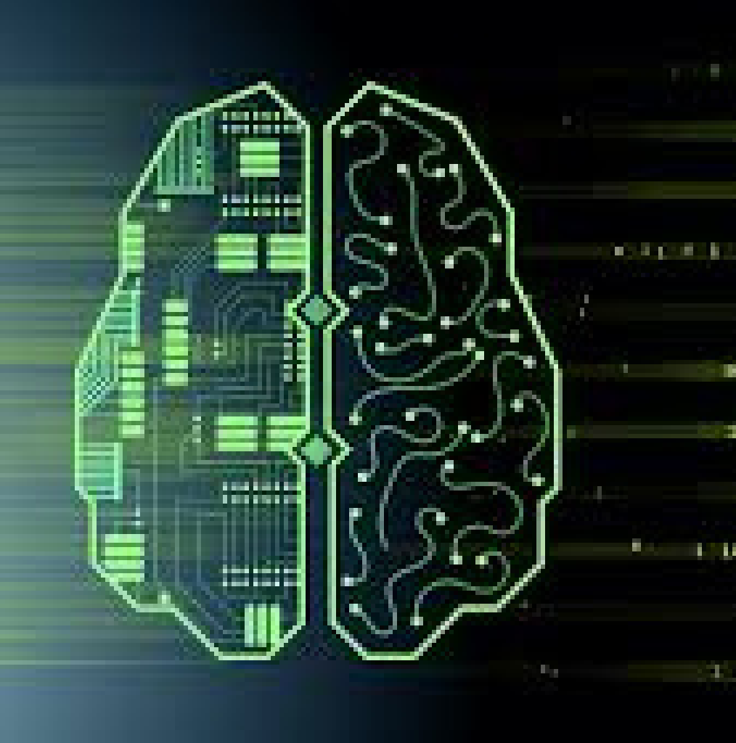

Machine Learning Course provided by Nettech India will help the candidate to be able to learn the different techniques and concepts, including mathematical and heuristic aspects, hands-on modelling to develop the algorithm and to ultimately prepare you for the job of machine learning engineer. Machine Learning is a quick and easy method to analyze a vast amount of complex data. The future of learning appears to be machine learning.

[h t t p s : / / n e t t e c h i n d i a . c o m /](https://www.nettechindia.com/)

# BENEFITS OF



**ML CERTIFICATION**

## Career Growth - Higher Pay & Position Encourages professional development Enriches self-image and reputation Enhances professional credibility.

Abundant Job Opportunities

## Used In Many Industries Global Recognition Secure and Flexible

50+ Case Studies

## 10+ Projects

[h t t p s : / / n e t t e c h i n d i a . c o m /](https://www.nettechindia.com/)

# COURSE CONTENT

1. **Introduction to Machine Learning** Introduction to Machine Learning Types of Machine learning

Data understanding: real-life example

Application of Machine Learning

 Discussion on different packages used for ML

Related concepts: Splitting the dataset into train set and test set Practical knowledge of the algorithm on Python

##### Introduction of Statistics

* Descriptive statistics: Measure of Central Tendency, Measure of Dispersion, Measure of Shape
* Probability and sampling: Conditional probability, Bayes theorem
* Probability Distribution
* Hypothesis Test

##### Packages of Machine Learning

* Numpy
* Pandas
* Matplotlib
* Seaborn

##### Exploratoy Data Analysis

##### Introduction to Graphs

##### Description about data

##### Visualisation

##### Data cleaning

##### Data prepressing

##### Scaling

##### Normaliztion

##### Standardization

##### Regression Techniques

Linear Regression Technique Dataset with problem description Non- Linear Regression Techniques Logistic Regression Technique

##### K-Nearest neighbours

K-Nearest Neighbors Concept and theory

Distance functions: Euclidean, Minkowski Why should we use KNN?

Mathematical approach

Dataset with problem description Practical application on Python

##### Support Vector Machine

Support Vector machine

Introduction to Support Vector Machine Mathematical Approach

Theory on hyperplane

Dataset with problem description Practical application on Python

##### Decision Tree

Introduction to Decision Tree Significance of using Decision Tree Different kinds of Decision Tree

Procedure and technique of Decision Tree

Practical application of Decision Tree on Python

##### Random Forest

Random Forest

Theory and mathematical concepts Entropy and Decision Tree

Dataset with problem description

Classification using random forest on Python

##### Naive Bayes

Introduction of Naïve Bayes Theory of classification

Concept of probability: prior and posterior Bayes Theorem

Mathematical concepts Limitation of Naïve Bayes Dataset with problem description

Practical application on Python

##### Clustering

Introduction of clustering K-mean clustering

* Hierarchical Clustering

Dataset with problem description

Practical application on Python

##### Gradient Descent

Gradient descent Stochastic GradientDescent

Gradient boosting

Types of boosting Bootstrapping

Practical application on Python

##### Dimensionality Reduction Techniques

##### Linear Discriminant Analysis (LDA)

##### Principal component Analysis (PCA)

##### Business case study

**15 Time Series Analysis**

* Introduction to time series
* Components of Time Series: Trend, Seasonal, Cyclical
* Types of Forecasting methods: Autoregressive Model, Moving Average Model, Autoregressive Integrated Moving Average Model, Seasonal Autoregressive Integrated Moving Average Model
* Practical application on Python

# WHO CAN LEARN ?

Anyone who wants to build a career as a Data Scientist. Anyone who wish to gain knowledge about Programming Students who are currently in college or university

# CAREER OPPORTUNITIES

ML engineer Data Scientist AI engineer

Business Intelligence Developer

Human Centered ML Designer Software engineer/developer **And Many More....**



**PROCESS FOR SUCCESS**

**GET PLACED**

**GET TRAINED**

**ENROLL**

# FACILITIES OFFERED



### Practical Training on Live Projects 100% Placement Guarantee Interview Preparation

Global Certification

### Fully functional labs Online / OfflineTraining Study Materials

Expert level industry recognized

### training

[h t t p s : / / n e t t e c h i n d i a . c o m /](https://www.nettechindia.com/)



203, Ratnamani Building, Dada Patil Wadi, Opp ICICI ATM, Near Platform No.1Thane, Maharashtra 400601

#### 9 8 7 0 8 0 3 0 0 4 / 5

i n f o @ n e t t e c h i n d i a . c o m

#### [h t t p s : / / w w w . n e t t e c h i n d i a . c o m](https://www.nettechindia.com/)